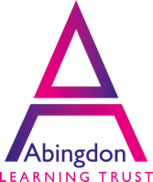 **Low Carbon Skills Fund grant secured**

Following application, in early autumn, the Trust was awarded just under £30000 as part of the Low Carbon Skills Fund. Over the last few months, detailed work has been undertaken to identify the routes towards energy decarbonisation in the Trust.

The fund provides grants to eligible public sector bodies to source specialist and expert advice to identify and develop energy efficiency and low carbon heat upgrades for non-domestic buildings.

The Trust is working closely with enFrame CIC and Veolia paid for by the grant.

On 17 March 2022, the Board formally received the Heat Decarbonisation report, which describes the Trust’s current energy use, and details how we can reduce and/or decarbonise our energy use.